Concept:
Developing a web base solution for online venue booking, which can be a search platform, directory and users can view, review and analyze about the venue options in market.
About:
www.clickmyvenue.com is venue discovering, promotion, management platform. It recommends venues for your events (Conferences, Exhibitions, Workshops, etc.) based on your occasion, capacity, budget, amenities and city.
ClickMyVenue connects people planning events with the right venues to meet their unique event needs. Our goal is to simplify and streamline the event booking process for both organizers and venues. We want you to take all the credit for a great event but do none of the work. Think of ClickMyVenue as your new best friend that always knows the best place to hold an event.

Web:
www.clickmyvenue.com

Reference Site: http://meravenue.com
http://venuebookingz.com
http://venuehub.hk
http://venuebook.com/
https://www.imbookin.com/
http://www.venuesonline.com
http://www.eventective.com/
http://www.meetingsbooker.com/
http://venueagent.com
http://www.cvent.com/rfp/
http://mpoint.starcite.com/rfp/home
http://eventup.com/
http://www.eventnow.com/
http://www.evenues.com/Venue-Finder
http://www.eventwist.com/
https://www.worktopia.com/
http://venuetastic.com/

Not launched:
http://venueforest.com/
http://partypie.com/
http://signup.venuescoutsf.com
Directories:
http://www.bizbash.com/venue-directory/
http://www.greatplacesdirectory.com/
http://www.gatheringguide.com/

For Venue Owners:
Why offer your venue for event bookings?
- It's free, and easy, to get your venue approved.
- Get complimentary Site Visits and Inquiries from potential bookers via our online messaging system.
- Make more money - be available 24/7 for booking requests.
- Pay 10-15% only when you receive a successful booking.
- Connect with a global audience via ClickMyVenue.com and its network of partner sites.
- When a booking request is submitted, you have 24 hours to accept or decline it.

Add Your Venue:
Log in, complete your profile, and submit your venue for approval.
Get approved:
We screen every venue for accuracy and legitimacy.
Start selling:
Add your pictures, connect your profile on LinkedIn/Facebook, confirm accuracy of availability, pricing, policies. (YOU are a huge part of what you sell!)
Communicate:
We connect you with those looking to book an event. We encourage communication via general questions and Site Visits.
Get booked:
Once you receive a booking request, you have 24 hours to accept or decline it. For your first bookings, you will be sent the deposit 24 hours after the event date.

For Users:
Site will be a data bank and search option for all categories venue option,
Options in Site:
- Venue Search
- Venue Details
  - Best Utility of Venue (Tick mark type of events) [ wedding, party, get to gather, social functions, corporate event, etc]
  - Category (INDOOR /OUTDOOR)
  - Size / Capacity of venue
  - Parking Facility
  - Power Back Up
  - Rooms Facility
  - Approx Cost
  - Availability for requested date (OPEN / BLOCKED / BOOKED)
  - Social Recommendation
- Decoration Option (Monopoly / Open) [if monopoly details of decorator]
- Catering Option (Monopoly / Open) [if monopoly details of caterer]
- Venue Photo
- Review
- Maps
Users can simply search venues around there locality or requested area, by just simply selecting CITY>> AREA>>INDOOR/OUTDOOR >>FUNCTION / EVENT TYPE>>APPROX GUEST????

Venue Category
- Hotel / Restaurant - Banquet Halls
- Clubs & Resorts
- Community Halls
- Party Plots
- Others

DIAGRAM:
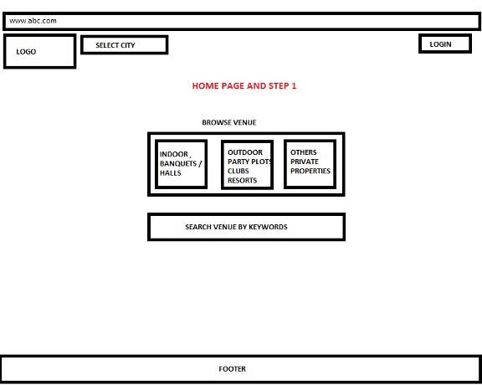

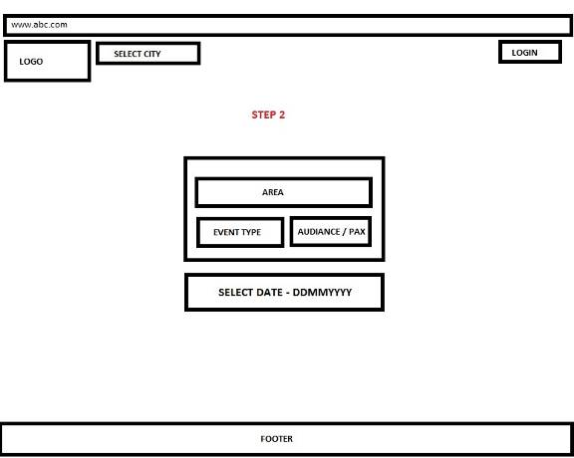

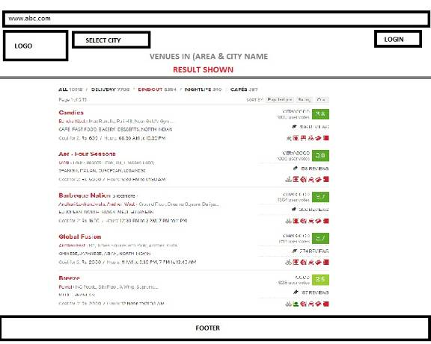

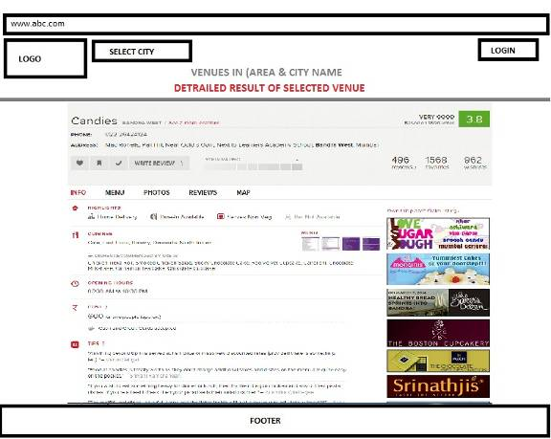

DIAGRAM 1: Home page with options / filter of Indoor (Banquets / Halls) or Outdoor (Party Plots/ Club / Resorts) or Other Option (Palaces, Farm House, Private Properties etc)

DIAGRAM 2: With selection of Diagram 1, option 2 comes with Area, Event Type, Approx Pax (Audience) and searching for Date.

DIAGRAM 3: After all required inputs the data will be fetched with results: Available, BLOCKED, and BOOKED ( Can be bifurcated with 3 different colors.

DIAGRAM 4: Selection of any option will open the entire detailed about that venue: Venue Name, Address, Contact Person, Contact No, Availability, Specification of Venue (Area, Size, etc..) Catering Details, Decorators Details, Parking Space, Power Back up, Wash Rooms,

If Available user can BLOCK the Venue for that date, for which he has to be signed in, after signed in he has to give details of Event Type, Time, and Verify with Mobile No & Email ID.

IF the event date is less than 30 days, user need to close (BOOK) with in 24 Hrs, and if its more than 30 days maximum 3 Users can BLOCK the venue..

If AMIT Has blocked 1st, SACHIN has blocked 2nd and DHONI has Blocked 3rd, Simultaneous sms will be send to all and AMIT Gets 24Hts, SACHIN Gets 2 Days and DHONI Gets 3 and more days to BOOK.

In case DHONI want to BOOK ON SAME DAY, He can Book by Token Confirmation Amount of Rs.1000 which will be Non Refundable and after 3 days he can get the venue booked conformed.

PHASE II

The Data input will be provided and filled by direct Venue Owner,

Data Basic Details:
- NAME OF VENUE
- ADDRESS
- AREA
- CITY
- PIN CODE
- STATE
- PHONE
- FAX
- EMAIL ID
- WEBSITE
- NAME OF OWNER
- MOBILE NO
- EMAIL ID
- NAME OF VENUE CONTRACTOR
- MOBILE NO
- EMAIL ID
- TYPE OF VENUE (SELECT – BANQUET HALL / CLUBS & RESORTS / PARTY PLOT / OTHERES)
- BEST FOR OCCUSIONS / EVENTS (CLICK WITH LIST OF SELECTION)
- FACILITES (PARKING / ELECTRICITY / WASHROOMS / DECORATION / CATERING ETC)
- IF MONOPOLY DECORATOR
  - NAME OF DECORATOR
  - ADDRESS
  - CITY > PINCODE
  - PHONE NO
  - OWNERE NAME
  - MOBILE NO
  - EMAIL ID
  - WEBSITE
  - DECORATION OPTION
- IF MONOPOLY CATERER
  - NAME OF CATERER
  - ADDRESS
  - CITY > PINCODE
  - PHONE NO
  - OWNERE NAME
  - MOBILE NO
  - EMAIL ID
  - WEBSITE
  - FOOD MENU AND OPTIONS
- BANK DETAILS

VENUE ADMIN / DASH BORD
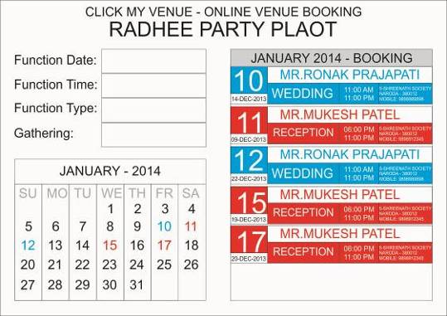

Project FAQ’s:

- Is your website URL venuebzaar.com?
  - www.clickmyvenue.com
- How many types of front end users will there be in the site? From the PPT I can understand that, but I need to know a clear role of each & every user of the site.
  - It is a open search portal still it is more focused for people who are in search for venue for there event, social gathering, parties etc..
- If possible please provide us a wireframe of the system? A hand-drawn image with menu & other details will be good enough. Check attached reference screenshot for what I meant.
- What is the menu system of the website? Need a detailed site map. Site map means Home/About Us/Search/booking etc.

- Seems like this is a market place for the vendors & clients. How mnay types of user registration will be there? Is there any paid or Free registration? What features will they have for a paiud v/s Free registrataion?
  - Its free for end user, but for Vendors its paid (For first year it will be free for all)
- Please provide the form that the client needs to fill to post a project (event). How will the vendors apply for the same? I just nee to know the system navigation that’s all.
  - http://www.zomato.com/information#add-restaurant
- Will there be any criteria to qualiofy for them to send a proposal. What I meant is, a client may be looking for an event worth Crores, but a small company has applied but probably he doesnot have adequate man power or experince to handle such kind of events, which can be risky, correct? So how to make sure of that? Fopr such cases the platform repuation might be at stake.
- What is the commission structure of the site? How will the system earn from the events?
- What specific admin panel functionality are you looking for? How many admins do you need? Do you have any concept of Admin/Super Admin etc? If yes please specify the detailed roles.
- Is there any specific role in the system for Host/Event Planner/Venue Manager & the Staff? Or only one person can apply for in the system on behalf of a company & have to work as all roles?
- What is the format to send a proposal to the client? Is there any option to reject a proposal?
- What will happen once the client accepts the proposal? Need a detailed system flow on this.
- Once a project is posted by the client is there any need for the Admin to check the project & approve & then gets it LIVE in the system?
- For how long vendors can submit proposals for the project?
- What will happen after a project gets posted but the client doesnot select anyone after a long time? Will that be expired or the project gets deleted from the system?
- How can the client contact a particular Vendor? Through chat or simple message?
- For such a market place, Support system is very important. What are the process of a dispute system incase the vendor failed to deliver what he promised?
- Will there be any ticket system? Customer care? If yes, how will the ticket system work? Who will reply to the ticket?
- Can the vendor & client share contact details with each other during discussion before project award?
- What is the payment gateway that you want to use?
- How do you want to tack even & client history? Refer Slide # 6
- How do you want the venuw search to happen in the site? Refer Slide # 6
- How to store event details in one place? Refer Slide # 6
- Is there any option to direct hire a vendor by the client?
- Is there any ratiung system for the users to determine the profile efficiency & all?
- Need a detailed erms of usage of the site.
- Do you need a Backend Content Management system for the site?
- Do you need SEO friendly pages? Do you need On Page SEO management from backend?
- Do you need Logo design as well? Please fill the attached doc, if you need it.

